Server

🖥️ What is a Server?
# Source: AI Source: Provided by: [Data Path: Persons Table -> ID Column: 1, Name_En Column: Motasem Essam] -> From: [ChatGPT] on [12/18/2025]
A server is a computer or system that provides resources, data, services, or programs to other computers, known as clients, over a network. It can be physical hardware or a virtual machine, and it's designed to run 24/7, handling requests and managing tasks like websites, databases, emails, files, and applications.
✅ A server “serves” data or services to clients on demand — in a local network or over the internet.

🔄 Client-Server Model (Simplified)
# Source: AI Source: Provided by: [Data Path: Persons Table -> ID Column: 1, Name_En Column: Motasem Essam] -> From: [ChatGPT] on [12/18/2025]
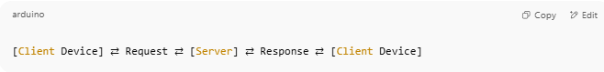
[Client Device] ⇄ Request ⇄ [Server] ⇄ Response ⇄ [Client Device]

For example:
- You visit a website → your browser (client) sends a request to a web server → the server responds with the page.

🧠 Types of Servers (by Function)
# Source: AI Source: Provided by: [Data Path: Persons Table -> ID Column: 1, Name_En Column: Motasem Essam] -> From: [ChatGPT] on [12/18/2025]
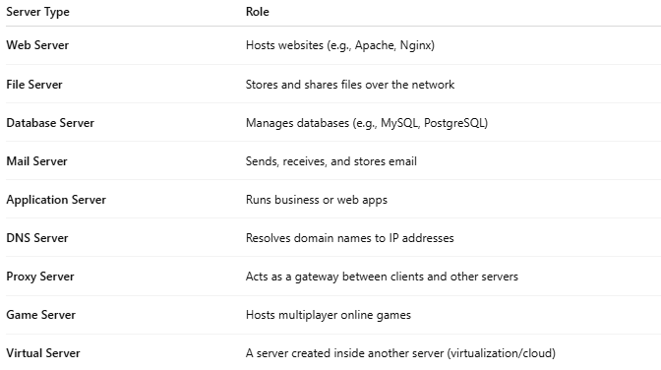
Server Type | Role
Web Server | Hosts websites (e.g., Apache, Nginx)
File Server | Stores and shares files over the network
Database Server | Manages databases (e.g., MySQL, PostgreSQL)
Mail Server | Sends, receives, and stores email
Application Server | Runs business or web apps
DNS Server | Resolves domain names to IP addresses
Proxy Server | Acts as a gateway between clients and other servers
Game Server | Hosts multiplayer online games
Virtual Server | A server created inside another server (virtualization/cloud)

🧱 Types of Servers (by Deployment)
# Source: AI Source: Provided by: [Data Path: Persons Table -> ID Column: 1, Name_En Column: Motasem Essam] -> From: [ChatGPT] on [12/18/2025]
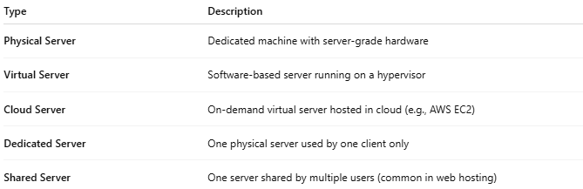
Type | Description
Physical Server | Dedicated machine with server-grade hardware
Virtual Server | Software-based server running on a hypervisor
Cloud Server | On-demand virtual server hosted in cloud (e.g., AWS EC2)
Dedicated Server | One physical server used by one client only
Shared Server | One server shared by multiple users (common in web hosting)

🔧 Server Features
# Source: AI Source: Provided by: [Data Path: Persons Table -> ID Column: 1, Name_En Column: Motasem Essam] -> From: [ChatGPT] on [12/18/2025]
- 📡 Network interface (often multiple NICs)
- 💽 High-performance storage (RAID, SSDs)
- 🔁 Redundancy (dual power supplies, failover)
- 🔐 Security controls (firewalls, encryption)
- 🕓 Uptime-focused design (24/7 operation)
- 👥 Multi-user access and permission control

✅ Advantages
# Source: AI Source: Provided by: [Data Path: Persons Table -> ID Column: 1, Name_En Column: Motasem Essam] -> From: [ChatGPT] on [12/18/2025]
- ✅ Centralized control and resource management
- ✅ Supports multiple users/devices simultaneously
- ✅ Scalable and customizable for different roles
- ✅ Automates data, apps, and services delivery

❌ Disadvantages
# Source: AI Source: Provided by: [Data Path: Persons Table -> ID Column: 1, Name_En Column: Motasem Essam] -> From: [ChatGPT] on [12/18/2025]
- ❌ Requires setup and maintenance
- ❌ Can be expensive (hardware, software, cooling, power)
- ❌ Needs security measures (firewalls, patching)
- ❌ Downtime can affect many users

📌 Summary
# Source: AI Source: Provided by: [Data Path: Persons Table -> ID Column: 1, Name_En Column: Motasem Essam] -> From: [ChatGPT] on [12/18/2025]
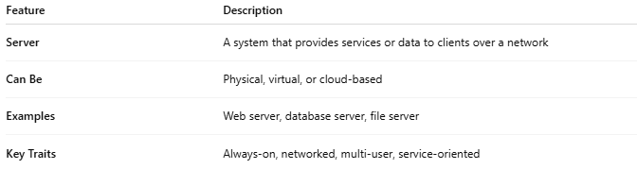
Feature | Description
Server | A system that provides services or data to clients over a network
Can Be | Physical, virtual, or cloud-based
Examples | Web server, database server, file server
Key Traits | Always-on, networked, multi-user, service-oriented

